AUTISTIC COMMUNICATION TOOL (A.C.T.) FOR USE IN PRIMARY CARE CONSULTATIONS

# Patient Name: Date:

**Instructions for Clinical Staff:**

Please read the information below. It provides essential information about my needs and experiences and is provided to help with communication within the consultation. Please read and return to patient. At the end of our consultation, kindly check if everything has been covered. Please note that autistic people can express pain differently and therefore body language and verbal expression may not be a good indication of the pain experienced.

**Please add a ‘Reasonable Adjustment’ flag to my patient record (Circle as appropriate) Yes / No / N/A**

**Communication Needs:**

**Factors to Consider for Physical Examinations:**

**Issue(s) to be discussed in consultation:**

# Front / Back

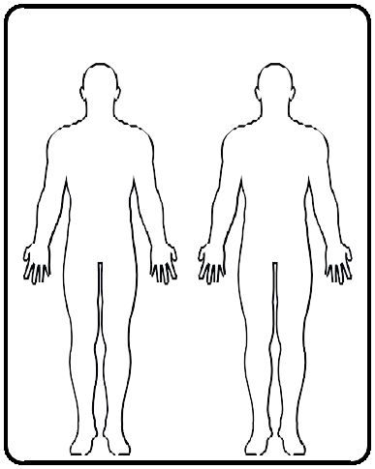

**Further details:**

**Other relevant conditions/medications to note:**

*For Healthcare staff: Please write details here of any next steps/advice received. This will help me remember and act upon advice. This might include details of medication or referrals.*

**Outcome of consultation (including actions by patient):**

**THE LIVERPOOL AUTISM HUB**

**Waiting Area**

If possible, I would like to wait in a quiet place.

If possible, I would like to wait in an area with low lighting?

If an appropriate place is not available, would it be possible for me to wait in the car/alternative place nearby and you ring me on when

my appointment is ready?

I would like to use noise-cancelling headphones in the waiting room to help me cope with the environment. I will not be able to hear an auditory call when my appointment time comes. Could you please alert me by:

Please may I be kept informed of waiting times or if the healthcare professional is running late.

Other:

**Tick as appropriate**



**THE LIVERPOOL AUTISM HUB**



**AUTISTIC COMMUNICATION TOOL (A.C.T.) FOR USE IN PRIMARY CARE CONSULTATIONS**

**Instructions for Care Navigators/Reception Staff:**

I would like to make you aware that I am autistic, and I sometimes find the areas designated for waiting prior to an appointment overwhelming. Where possible, please provide me with the following reasonable adjustments:

**Signs of me being overwhelmed whilst waiting:**

I may become overwhelmed being here, especially if there is too much noise/light/waiting time. When I am distressed, I may:

In order to help me, I would like you to: